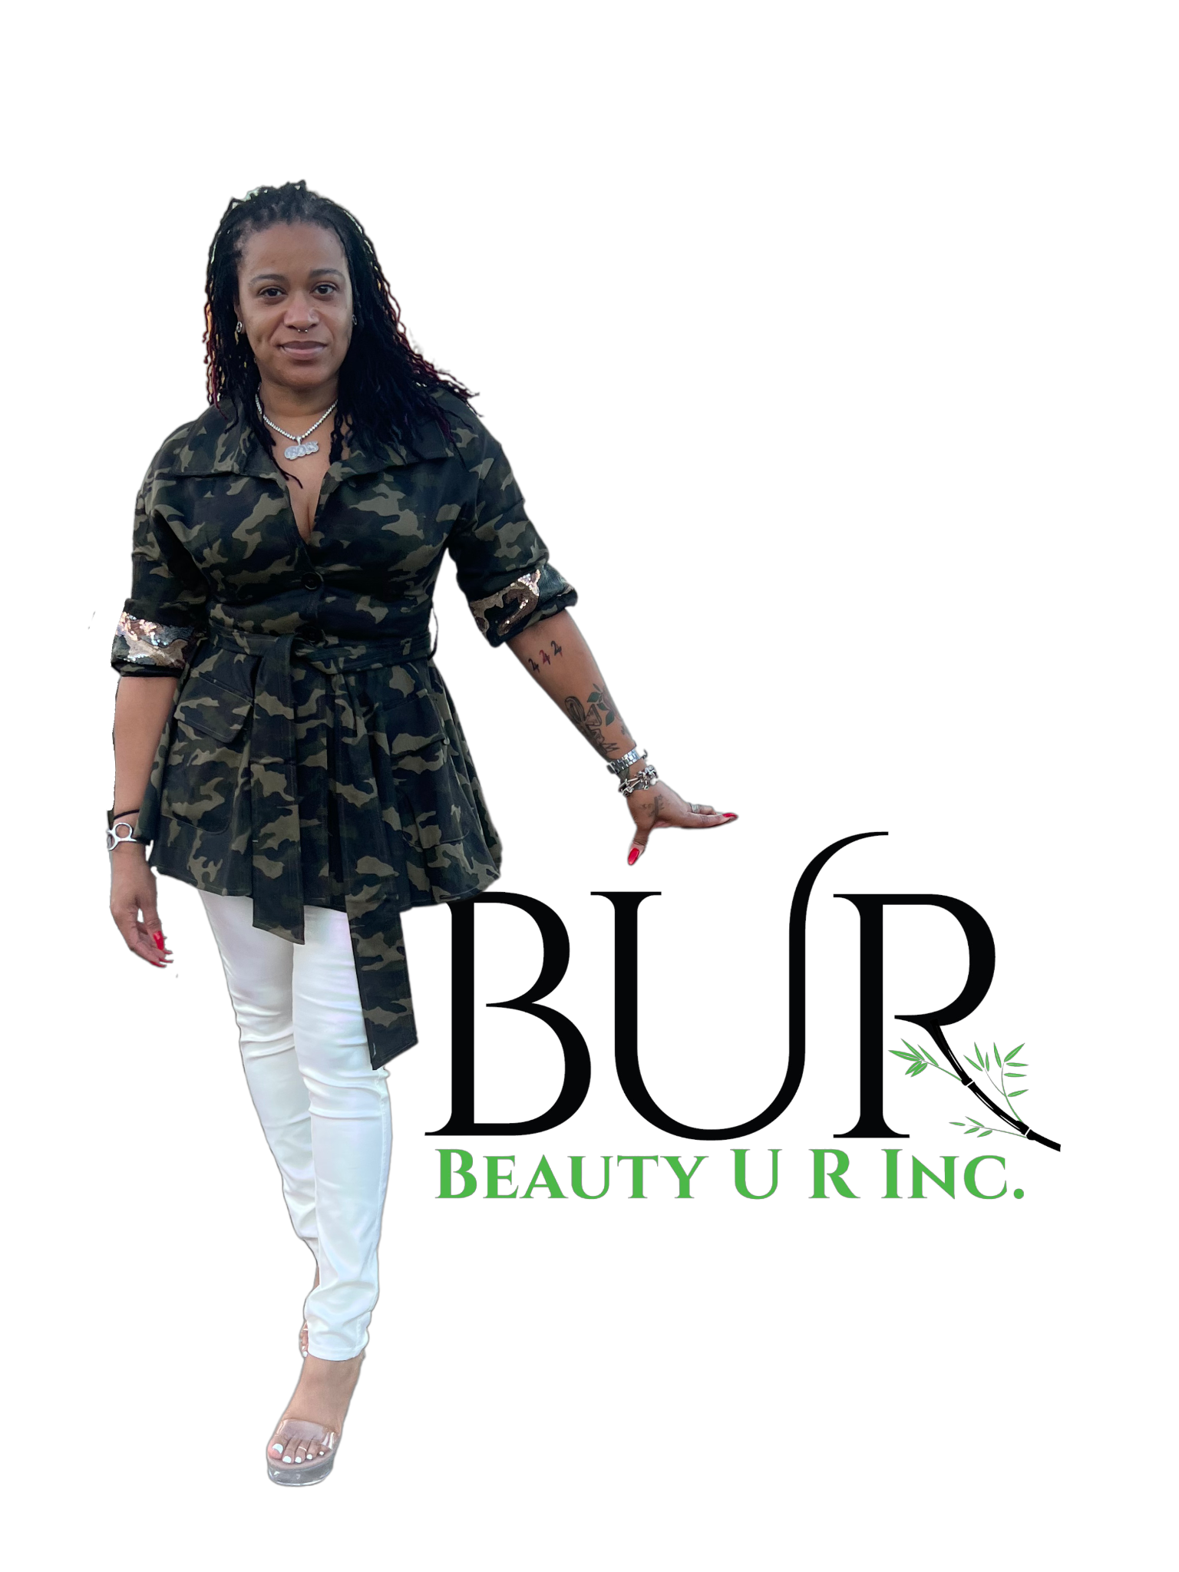TERMS AND CONDITIONS

Outlined are the terms and conditions regarding participation in the Traveling Boutique service offered by BEAUTY U R Inc. The traveling boutique is exclusive to merchandise sold by www.beautyur.com. Party hosts are in a favorable position to shop for merchandise that fits the taste and style of their guests and potentially drive more sales. The party package the host chooses from determines the level of commission or earnings received from the party. There are currently three levels of parties that can be selected. All parties include a set-up fee that will be outlined in further detail below.

Parties are outlined as follows:

Charming Party:

- The host can shop for up to $250 in merchandise to be showcased for their party.
- Online access to beautyur.com will also be available during the party.
- !0% of total sales will be given to the host in the method discussed by the Hostess and BEAUTY U R team member at the time of booking. These methods include checks, cash, cash app, Zelle, or Paypal.
- Total sales include physical items at the boutique and online shopping during the scheduled party.
- The charming party comes with a 2-hour time window. If additional hours are decided at the party, there will be a $60 fee per additional hour.
- A fashion-related icebreaker will be played during the party
- Recommended having at least 3-5 guests for a successful party at the Charming level.
- If you have at least 1 guest schedule a Traveling Boutique party, we will offer $50 off our Silver 360 package for your future event.
- There is a $50 setup fee for the Charming Party due when the party is booked.

Beautiful Party

- The host can shop a minimum of $251 and a maximum of $500 in merchandise to be showcased for their party.
- Online access to beautyur.com will also be available during the party.
- 20% of total sales will be given to the host in the method discussed by the Hostess and BEAUTY U R team member at the time of booking. These methods include checks, cash, cash app, Zelle, or Paypal.
- Total sales include physical items at the boutique and online shopping during the scheduled party.
- The beautiful party comes with a 3-hour time window. If additional hours are decided at the party, there will be a $60 fee per additional hour.
- A fashion-related icebreaker will be played during the party.
- Recommended having at least 5-10 guests for a successful party at the Beautiful level.
- In addition, you will receive $100 off a Gold or above 360 photo booth package.
- There is a $75 setup fee for the Beautiful Party due when the party is booked.

Lavish Party

- The host can shop for up to $501 - $1000 in merchandise to be showcased for their party.
- Online access to beautyur.com will also be available during the party.
- 30% of total sales will be given to the host in the method discussed by the Hostess and BEAUTY U R team member at the time of booking. These methods include checks, cash, cash app, Zelle, or Paypal.
- Total sales include physical items at the boutique and online shopping during the scheduled party.
- The charming party comes with a 4-hour time window. If additional hours are decided at the party, there will be a $60 fee per additional hour.
- A fashion-related icebreaker and 1 game will be played during the party,
- Recommended having at least10 or more guests for a successful party at the Lavish level.
- In addition, you will receive $175 off your Gold package or above 360 Photo Booth booking.
- There is a $100 setup fee for the Lavish Party due when the party is booked.

Cancellations:

Parties canceled after 72-hour notice will forfeit your set-up fee deposit. Parties canceled at least 72 hours in advance are eligible for a full refund of the set-up fee cost. If two cancellations are made you will not be able to schedule a party with BEAUTY U R for a minimum of 6 months.

Shopping Your Party

Shopping your party confirms your booking, which is when the set-up fee is expected to be paid. We have an array of items from women's fashion and accessories to jewelry along with travel bags. BEAUTY U R boutique truly offers a unique Boutique experience that you can share with your friends and family. Your shopping call can go a couple of ways.

Webinar - Webinar will allow you to view items online with a BEAUTY U R representative as well as getting know pieces that have not been featured online yet. This option works best if you have no idea what to offer your guest or if you are not familiar with our website.

Phone Call - A phone call can be scheduled if you have an idea of what you want to include in your Traveling Boutique party.

Merchandises selected for a party are subject to change. If we have clients who want items on your party list before you have your party, those items will not be held. Items sold before your party, Host, can be replaced with an item equal in value.

___________________________________________________________________

